CORNELL NOTES  MAIN IDEAS\  QUESTIONS | UNIT E, CHAPTER 2.1 -  Chemicals reactions that place inside cells  NOTES:
Carbohydrates  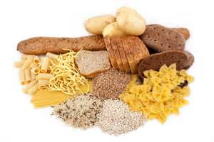 | Carbohydrates are sugars and starches, which provide energy for humans and animals, and cellulose which make up many plant structures.
Protein  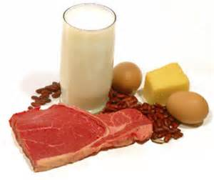 | Protein is made up of amino acids which are known as the building blocks of protein and are a source of energy. There are about 20 different amino acids but there are 8 essential amino acids.
Fat  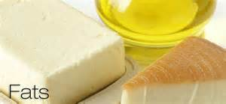 | Any of a heterogeneous group of lipids and fatlike substances, including, fatty acids, neutral fats, waxes, and steroids, which are water-insoluble and are a source of energy.
Vitamins  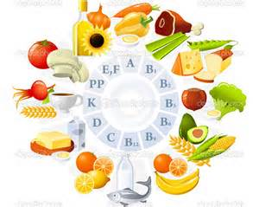 | A small organic molecule that your body needs to carry out certain reaction.
Minerals  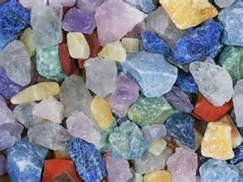 | A naturally occurring substance that is solid and inorganic and found in the ground.
Water  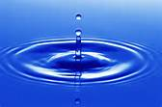 | A clear, colorless, odorless, and tasteless liquid essential for most plant and animal life and the most widely used of all solvents.
Chemical Energy  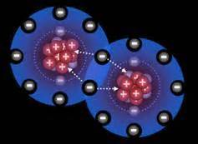 | The energy stored in the bonds between atoms of every molecule.
Thermal Energy  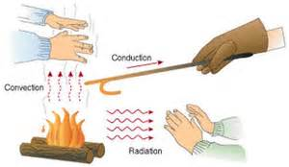 | The internal energy of an object due to the kinetic energy of its atoms and/or molecules.
Glucose  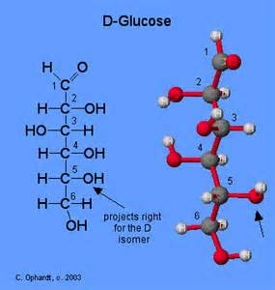 | A simple sugar that provides the body with its primary source of energy.
Photosynthesis  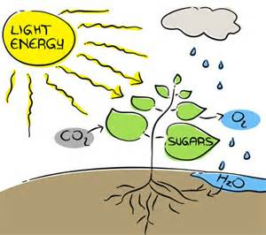 | The process that plant cells use to change the energy from sunlight into chemical energy.
Chlorophyll  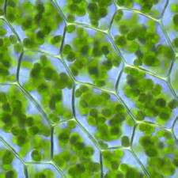 | A light absorbing chemical, or colored substance that traps the energy in sunlight.
Cellular Respiration  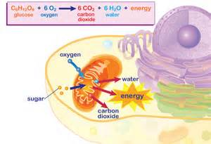 | The process where cells use oxygen to release energy stored in sugars such as glucose.
Fermentation  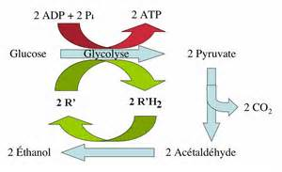 | The process by which cells release energy without oxygen.
Mitochondria  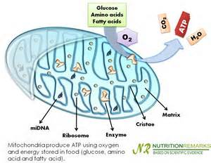 | Organelles that use oxygen to break down sugars to release energy.
SUMMARY

