CORNELL NOTES  MAIN IDEAS\  QUESTIONS | UNIT A: CHAPTER 2 - ENERGY  NOTES:
Law of Conservation of Energy | States that energy cannot be created nor destroyed but it can be transferred.
Energy Transfer  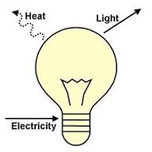 | The change of energy from one form to another.
Kinetic Energy | The energy that an object possesses because of its motion.
Mechanical Energy | The energy associated with the motion and position of an object.
Electromagnetic Energy  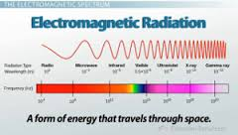 | Energy that can be reflected or emitted from objects through electrical or magnetic waves traveling through space.
Sound Energy  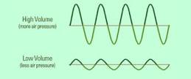 | The movement of energy through substances in longitudinal waves.
Potential Energy | The energy that is stored in an object due to its position.
Nuclear energy  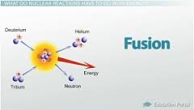 | The energy stored in the nucleaus of an atom. It can only be released through nuclear fission, nuclear fusion, or radioactive decay.
Elastic Potential Energy  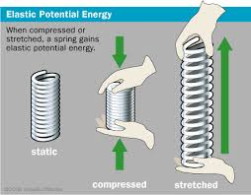 | The energy stored in stretched or compressed objects.
Chemical Potential Energy 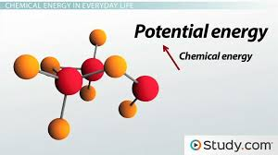 | Energy stored within the chemical bonds of atoms.
Thermal Energy  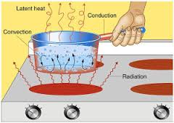 | The internal energy of a substance due to its heat.
Gravitational Potential Energy  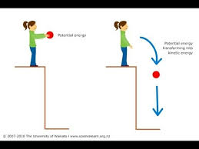 | The energy that an object possesses due to its position and the pull of gravity on that object.
Elastic Potential Energy

SUMMARY

