CORNELL NOTES  MAIN IDEAS\  QUESTIONS | UNIT E, CHAPTER 5  Characteristics of Bacteria, Viruses, Fungi, and Parasites  NOTES:
Microbiology | The branch of biology that studies microorganisms and their effects on other living organisms.
Microbe  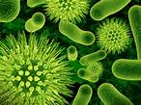 | A microscopic living organism (bacterium, fungus, protozoan; microorganism).
Unicellular 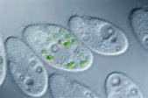 | Pertaining to an organism whose functions are all carried out within one cell.
Multicellular  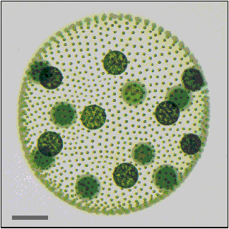 | Having or consisting of many cells or more than one cell to perform all vital functions.
Prokaryotic  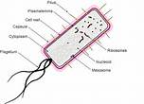 | An organism whose cell generally lacks a true nucleus and its genetic material is contained within the cytoplasm.
Eukaryotic  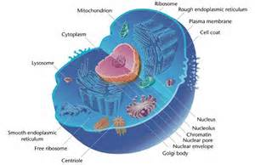 | Any organism whose cells contain a nucleus and other structures (organelles) enclosed within membranes.
Bacteria 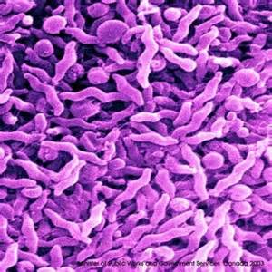 | Bacteria lack a membrane-bound nucleus and other internal structures and are therefore ranked among the unicellular life forms called prokaryotes.
Protozoa 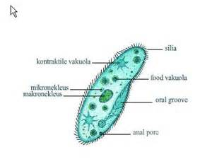 | A diverse group of mostly motile unicellular eukaryotic organisms.
Fungi | Any member of a large group of eukaryotic organisms that includes microorganisms such as yeasts and molds as well as the more familiar mushrooms.
Algae | A very large and diverse group of eukaryotic organisms, ranging from unicellular diatoms to multi-cellular forms such as the giant kelp.
Viruses 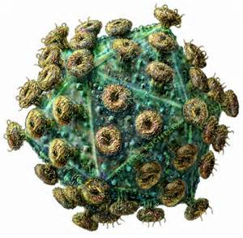 | A small, non-living, infectious agent that replicates only inside the living cells of other organisms. Viruses can infect all types of life forms, from animals and plants to bacteria.
Pathogens | Anything that can cause disease.
Infection 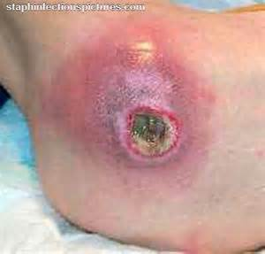 | The invasion and multiplication of microorganisms in body tissues.
Contamination 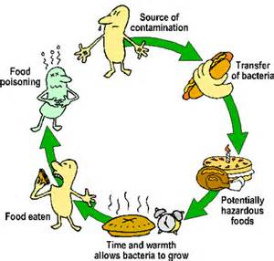 | The presence of extraneous, especially infectious, material that renders a substance or preparation impure or harmful.
Host Cell 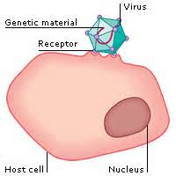 | A cell that harbors foreign molecules, viruses, or microorganisms. For example, a cell being host to a virus.
Vectors 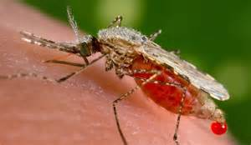 | A biotic agent that disperses reproductive structures of another organism, as a bee transmitting pollen to the stigma of a flower.
Epidemic 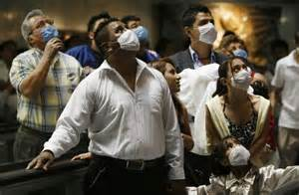 | The rapid spread of infectious disease to a large number of persons in a given population within a short period of time, usually two weeks or less.
Pandemic | An epidemic of infectious disease that has spread through human populations across a large region; for instance multiple continents, or even worldwide.
Vaccine | A weakened or dead form of pathogen.
SUMMARY

